UCAIug ITCA Green Button Data Custodian Connect My Data Test Sheet  
Revised: 7/13/2017 11:34 AM

# Overview

This document contains the test data sheet and procedures for performing the Green Button Data Custodian Connect My Data certification tests for UCAIug.

## References

1. The Green Button Test Cases Spreadsheet: <http://files.gbitca.org/test-cases>
2. The latest version of this Data Test Sheet: <http://files.gbitca.org/dc-cmd-test-data-sheet>
3. The policies and procedures for the UCAIug ITCA for Green Button: <http://files.gbitca.org/certification-policies-procedures>
4. Application for testing: <http://files.gbitca.org/dc-cmd-cert-form>

# Tests

## Identification

Fill out the following table (*italics* fields come from the test application):

|  |  |
| --- | --- |
| Test Date: |  |
| Certification Lab: |  |
| *CMD Test Software Version:* |  |
| *Company:* |  |
| *Product Name:* |  |
| *Product Version:* |  |
| *Function Blocks (FBs) to be Tested:* |  |
| *Company Representative (Testee):* |  |
| *Test Lab Engineer (Tester):* |  |
| *Certificate Identifier:* |  |

## Data Custodian CMD Environment Login

The Green Button Data Custodian Connect My Data Certification test uses an Amazon AWS Ubuntu Instance to perform the Certification testing. As part of the CMD Certification Application processing, the Green Button Alliance created a Certification Configuration script that automates the certification environment setup process for the Certification Test Lab Engineer. The following steps describe how the Test Lab Engineer connects to the Amazon AWS Ubuntu environment and the commands to be issued prior to starting the certification test

Procedure:

1. Using the installed VNC Viewer application connect and login to the Data Custodian CMD Certification AWS Instance by clicking on the window entitled “GBA Data Custodian CMD Certification AWS Instance” (shown on the left in the following screen capture).  
   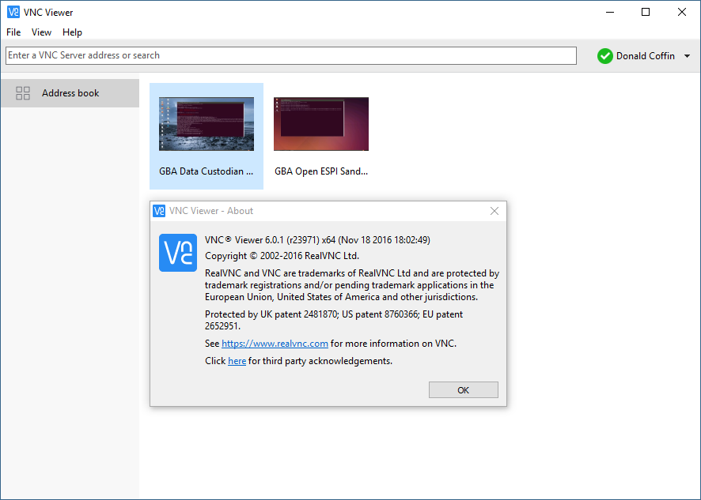
2. Perform the next set of steps only if the following screen appears otherwise proceed to step (3):  
   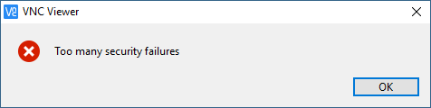
   1. Using PuTTY select the Data Custodian CMD Certification AWS Instance
   2. Select the “Load” Button
   3. Select the “Open” Button  
        
      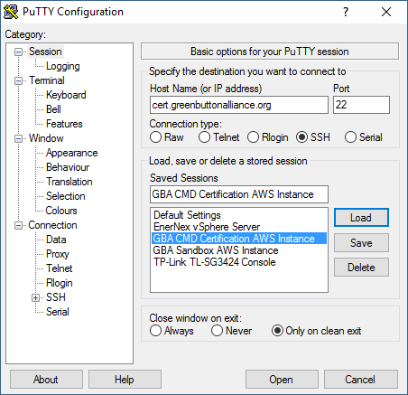
   4. The following screen will appear  
      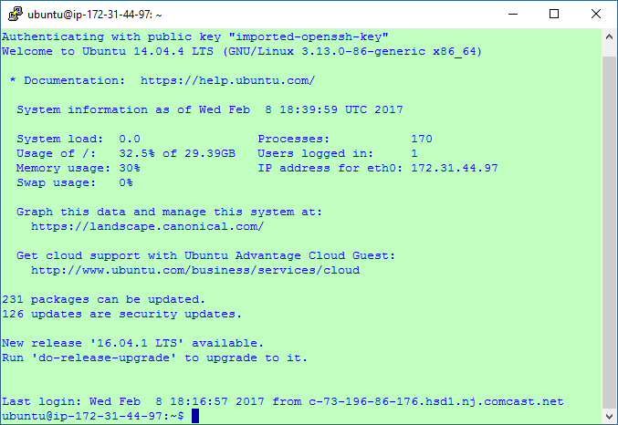
   5. Enter**./restartvnc.sh** (be sure to enter the (dot) (slash)
   6. The following output should appear  
        
      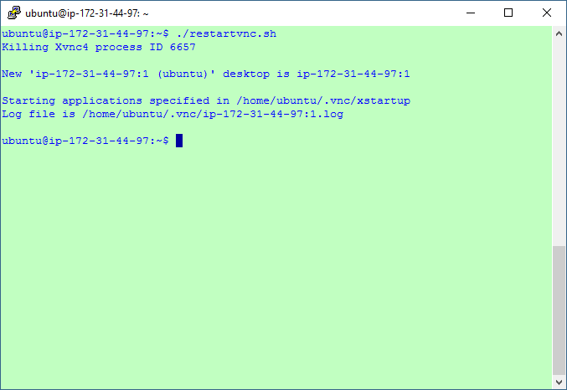
   7. If the above screen text does not appear, re-enter “./restartvnc.sh” until it appears.
   8. Restart the procedure at step (1)
3. When the following screen appears enter **gba2016!** in the “Password:” window and select “OK”
4. 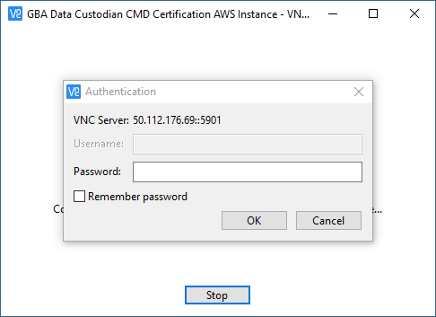  
   Selecting “Remember password” box before selecting OK will bypass the above screen on subsequent connection attempts.
5. The following screen will appear indicating the Certification Test Engineer has successfully established a session with the Data Custodian CMD Amazon AWS Instance  
   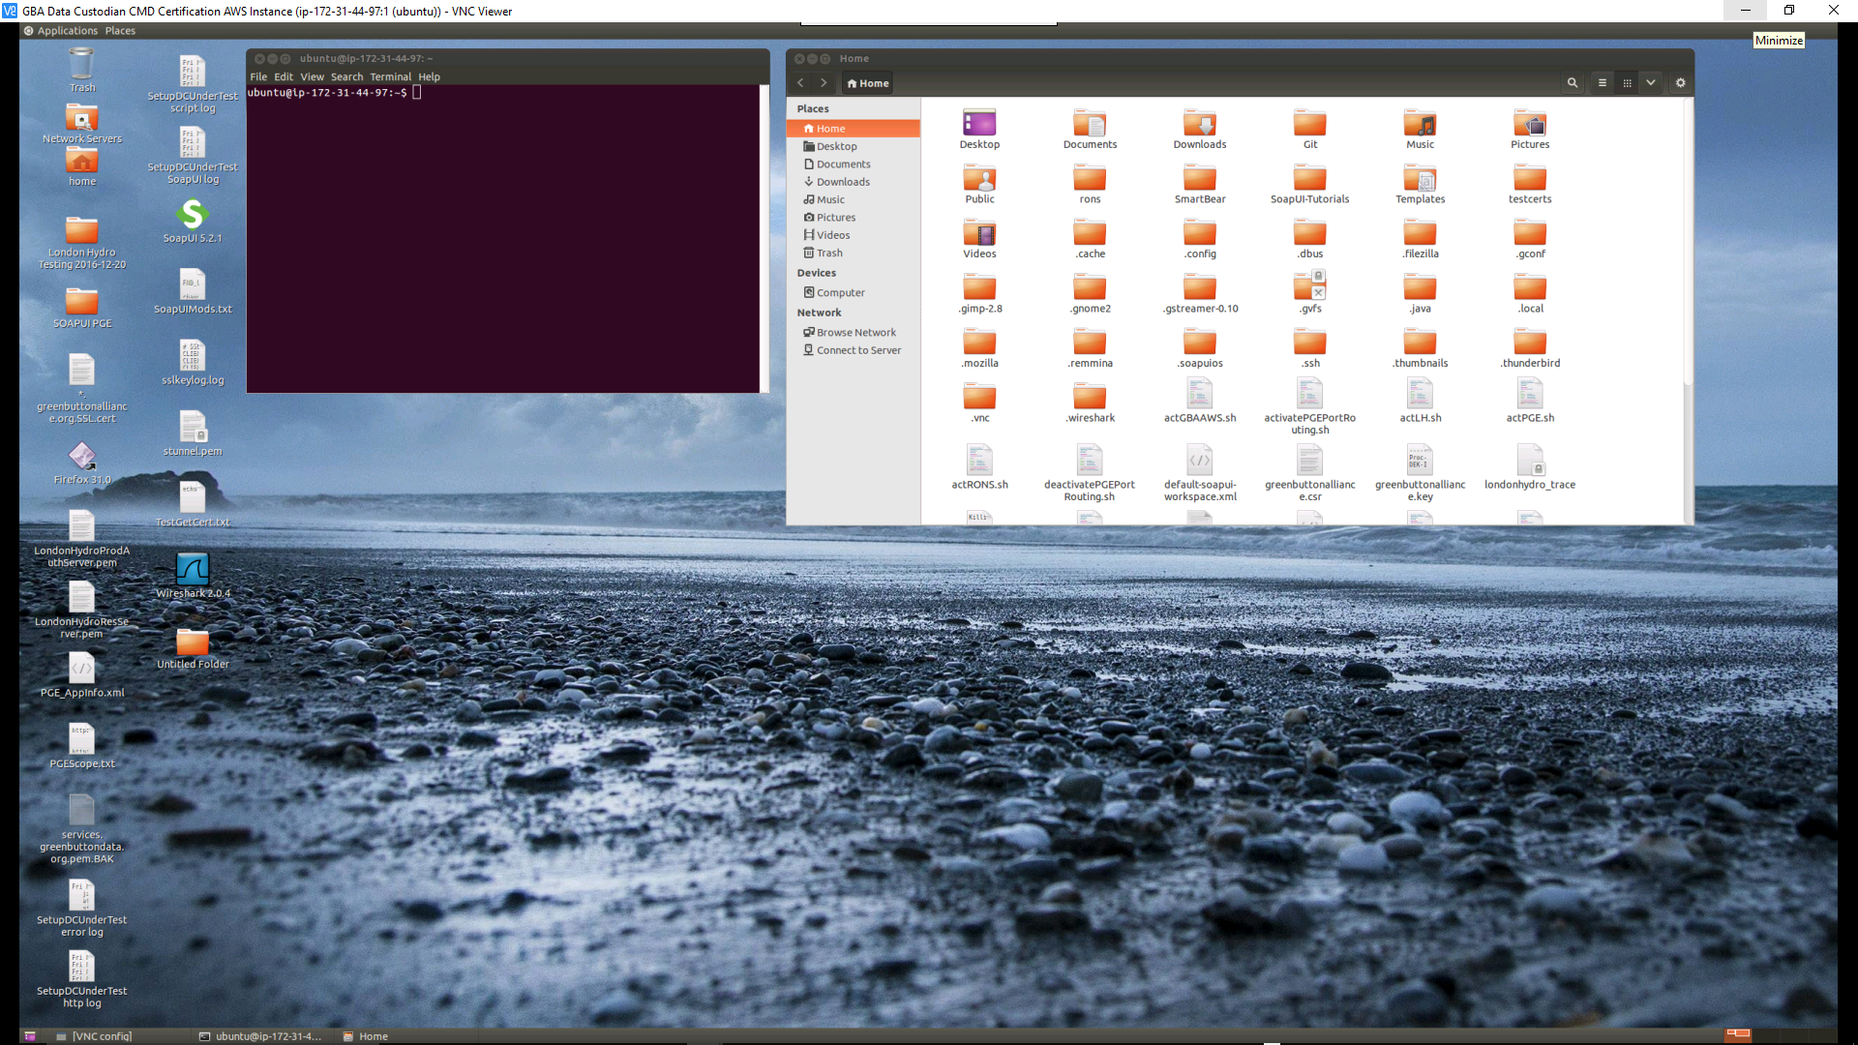

## Data Custodian Certification Test Initialization

This section describes the steps the Certification Test Engineer needs to follow once they have successfully logged into the Data Custodian CMD Amazon AWS Instance

Procedure:

1. Locate the window entitled **ubuntu@ip-172-31-44-97:~**
2. Enter the contents of the **Certification Config Command** in the For GBA Use Only section of the Data Custodian CMD Certification Application Form  
   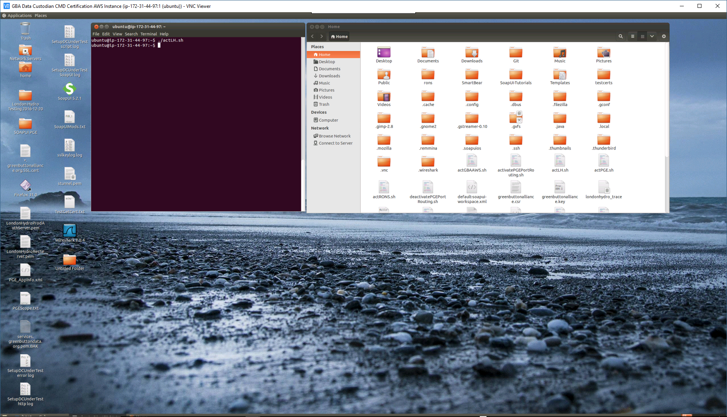  
   **(./actLH.sh** -- Certificate Config Command shown in terminal window above)
3. Locate the **SoapUI 5.2.1** Icon on the desktop
4. Click the **SoapUI 5.2.1** Icon
5. The following application should appear  
     
   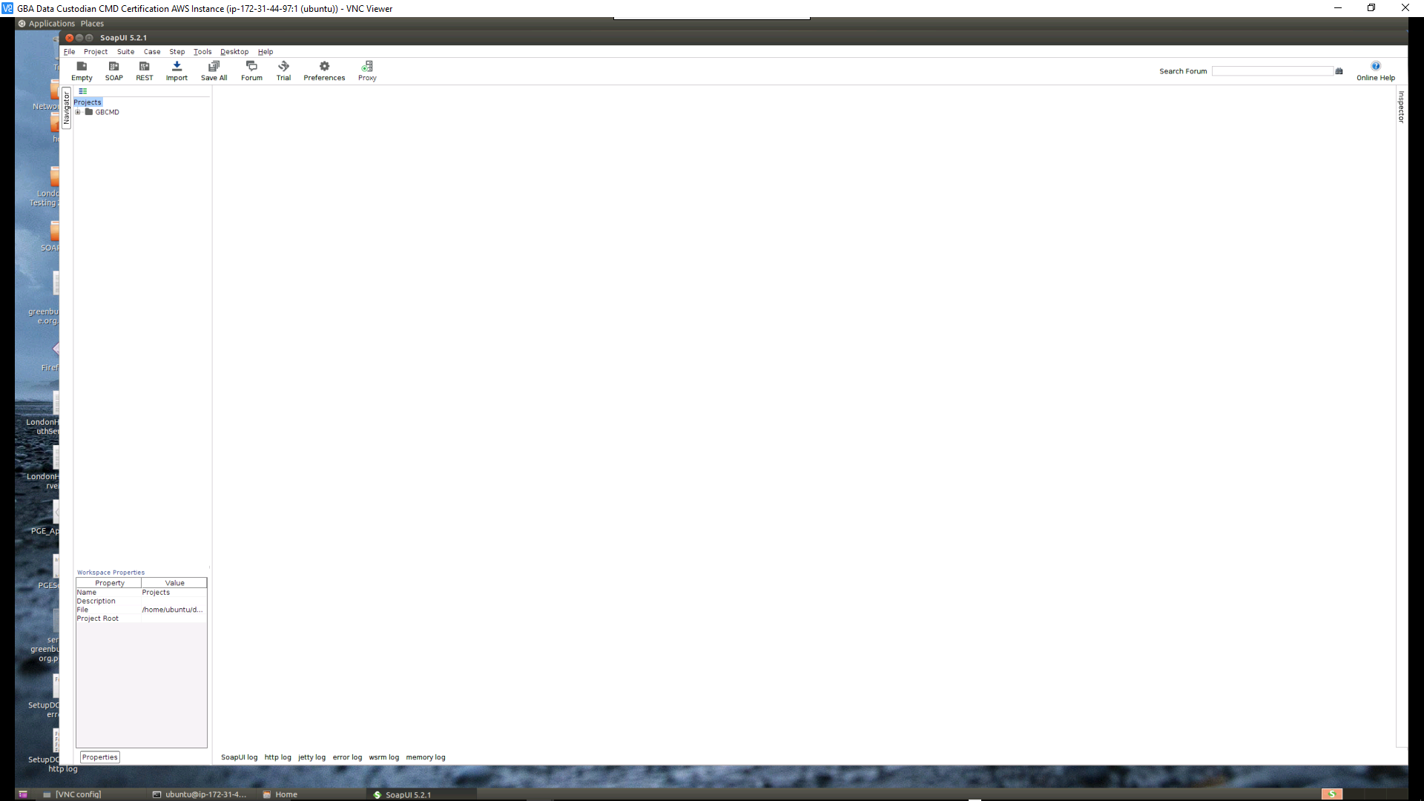
6. Click the **Boxed Plus Sign** next to the **GBCMD** entry
7. The following screen will appear  
   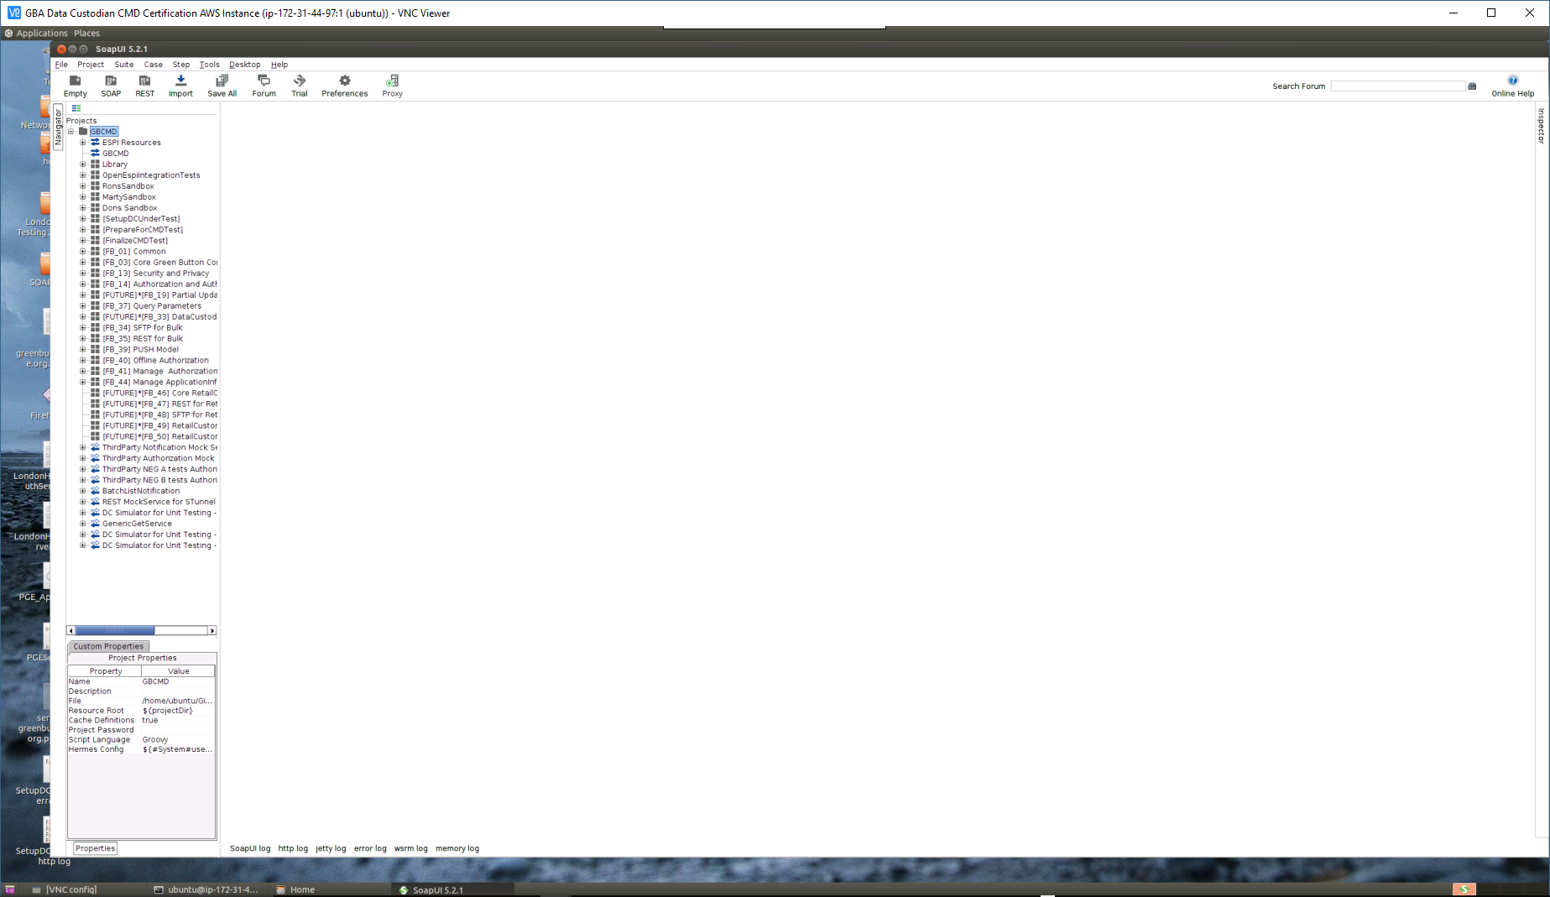
8. Locate **[SetupDCUnderTest]** and click it
9. The following screen will appear  
   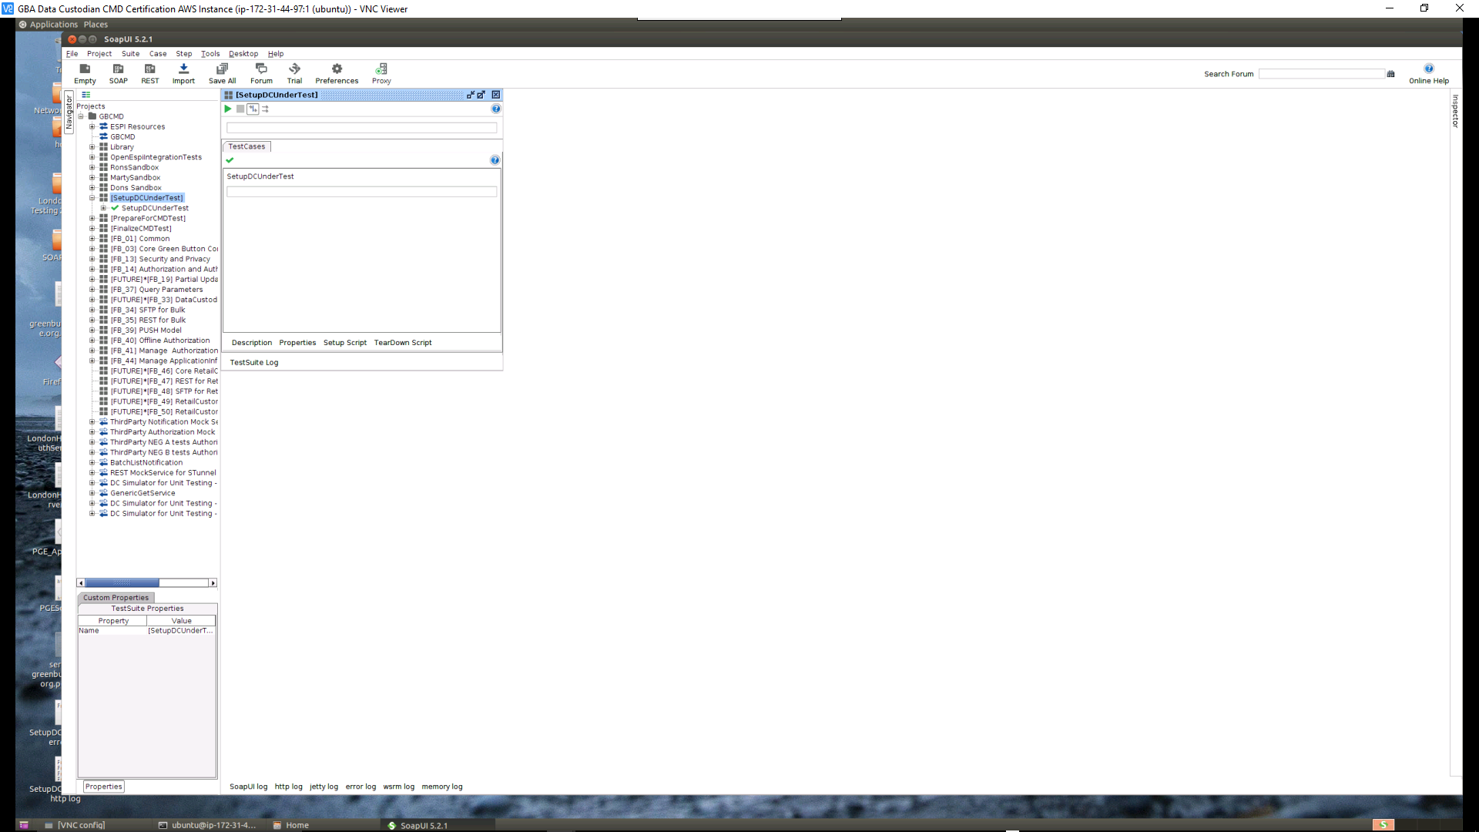
10. Click the Green Triangle in the upper left-hand corner of the window to execute the test
11. The following screen should appear when the **[SetUpDCUnderTest]** completes  
      
    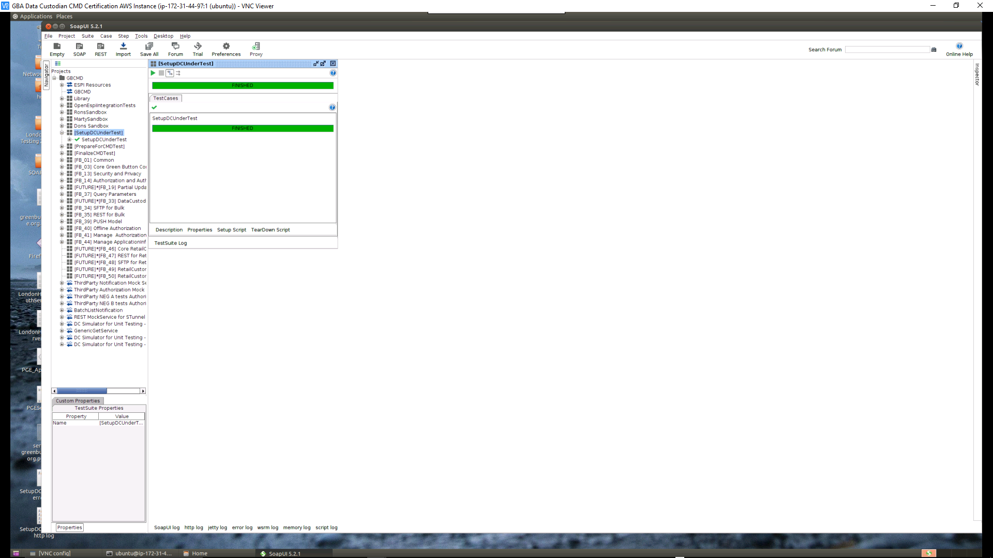  
    (Should the step **FAIL** – rerun the step until the above screen appears)
12. Locate **[PrepareForCMDTest]** and click it
13. The following screen will appear  
    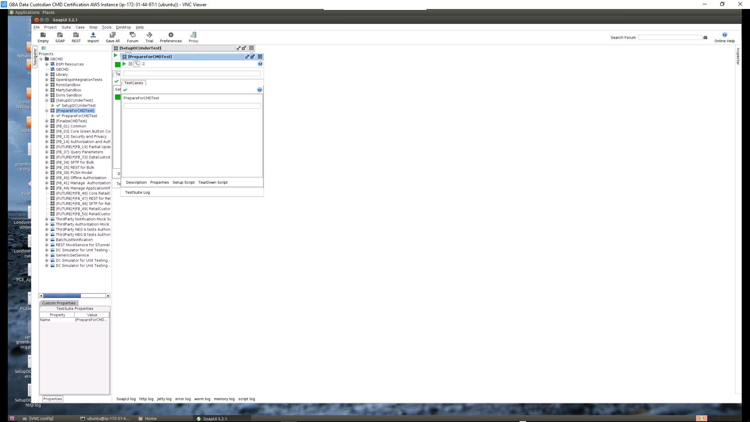
14. Click the Green Triangle in the upper left-hand corner of the window to execute the test
15. The following screen should appear when the **[PrepareForCMDTest]** completes  
      
    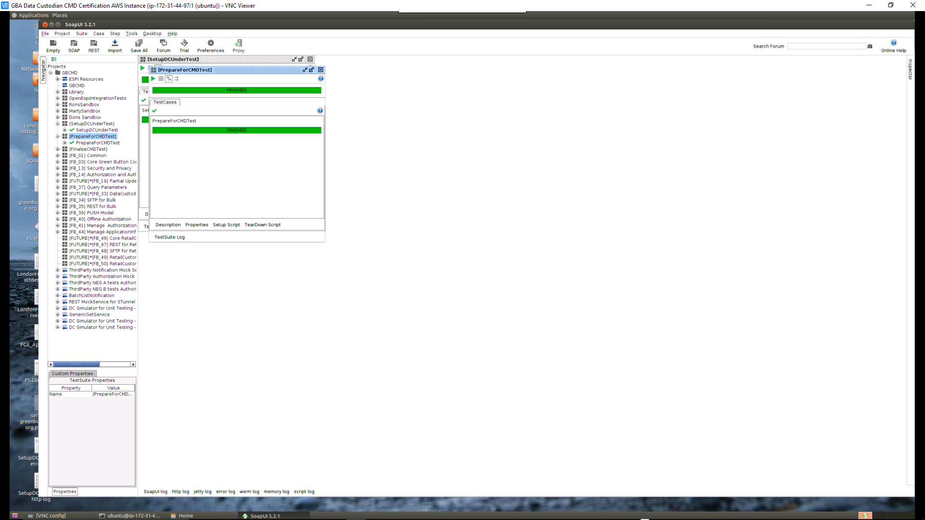

## Data Custodian Certification Test Execution

This section contains instructions for the execution of the test applicant’s requested Data Custodian Certification Function Blocks. This is a repetitive manually initiated process based on the Function Blocks selected by the test applicant on their Data Custodian Connect My Data Certification Application

Procedure:

1. Repeat the following steps for each Function Block [FB] selected by the test applicant on their Data Custodian CMD Certification Application
   1. Locate the line on the CMD Test software that matches the selected Function Block [FB_xx] and click it
   2. Click the Green Triangle in the upper left-hand corner of the window to execute the test
   3. Follow all instructions that appear in the **Dialog Boxes** and **Browser** window during the test
   4. When the test completes either a **FINISHED** or **FAILED** will appear at the top of the test window to indicate the status of the testing.
2. When all selected Function Block [FB] tests have finished. Perform the following to complete the Data Custodian Certification Test
   1. Locate **[FinalizeCMDTest]** and click it
   2. A screen like the following will appear (difference depends on number of Function Block [FB] tests performed)  
        
      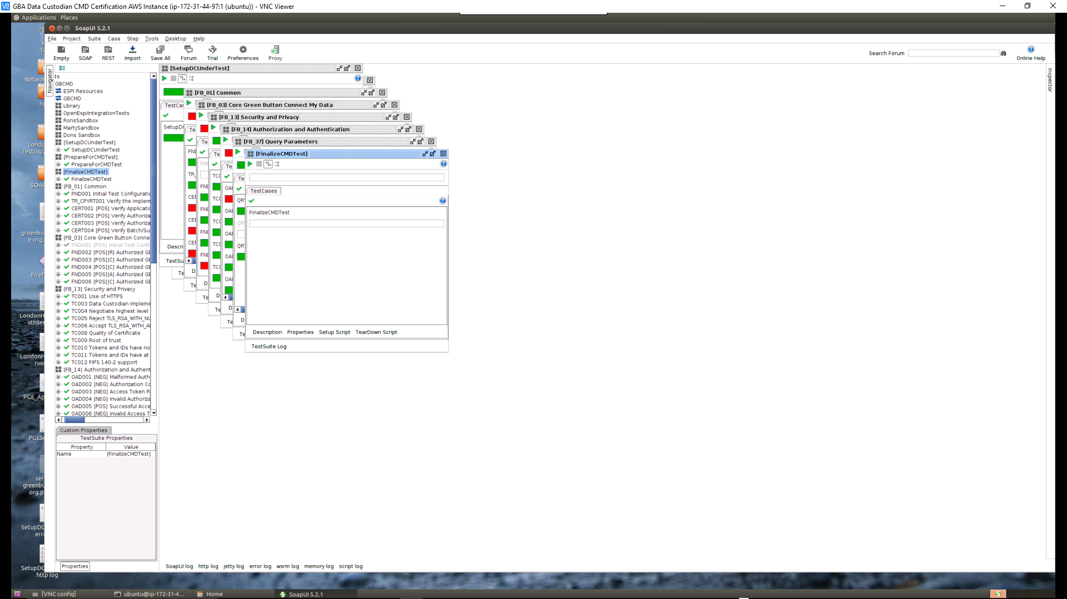
   3. Click the Green Triangle in the upper left-hand corner of the window to execute the test
   4. The Data Custodian CMD Certification Test is now completed

# Summary of Results

This section describes how to capture the results of the Data Custodian CMD Certification Test just concluded.

## Results of testing

Procedure:

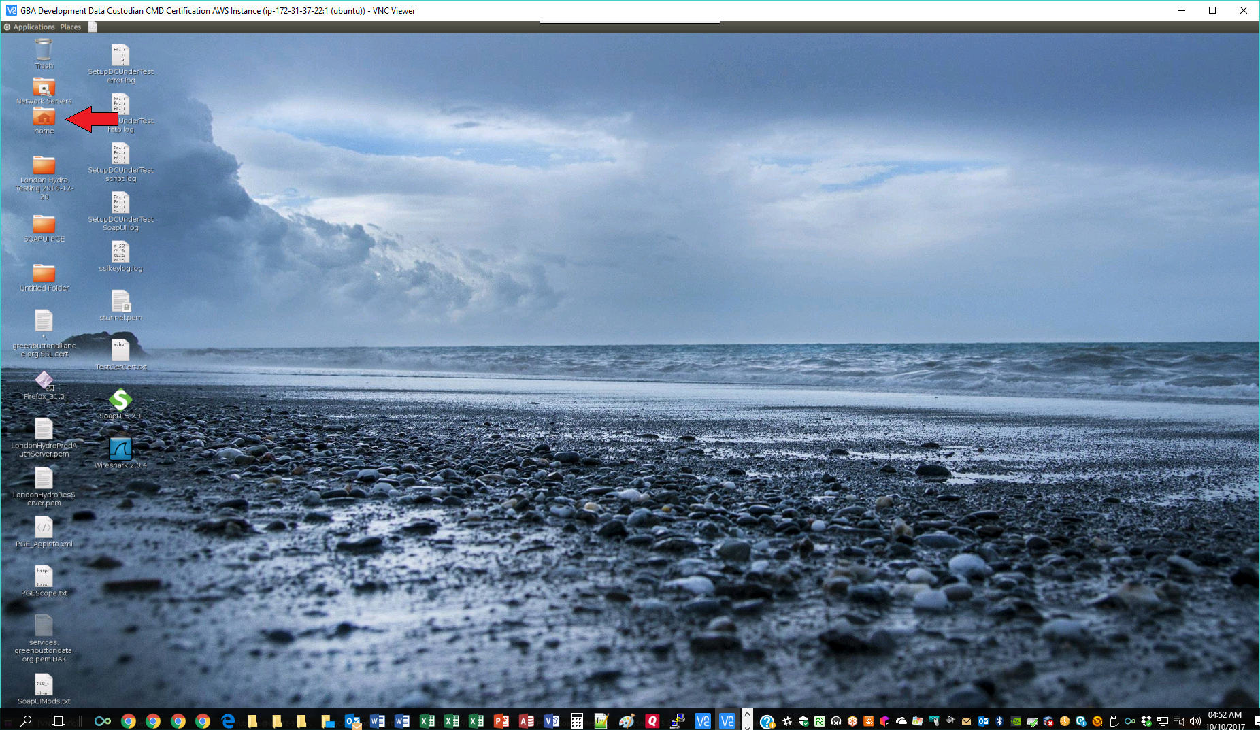

1. Click on the folder labeled “home” on the desktop to open a Files window
2. 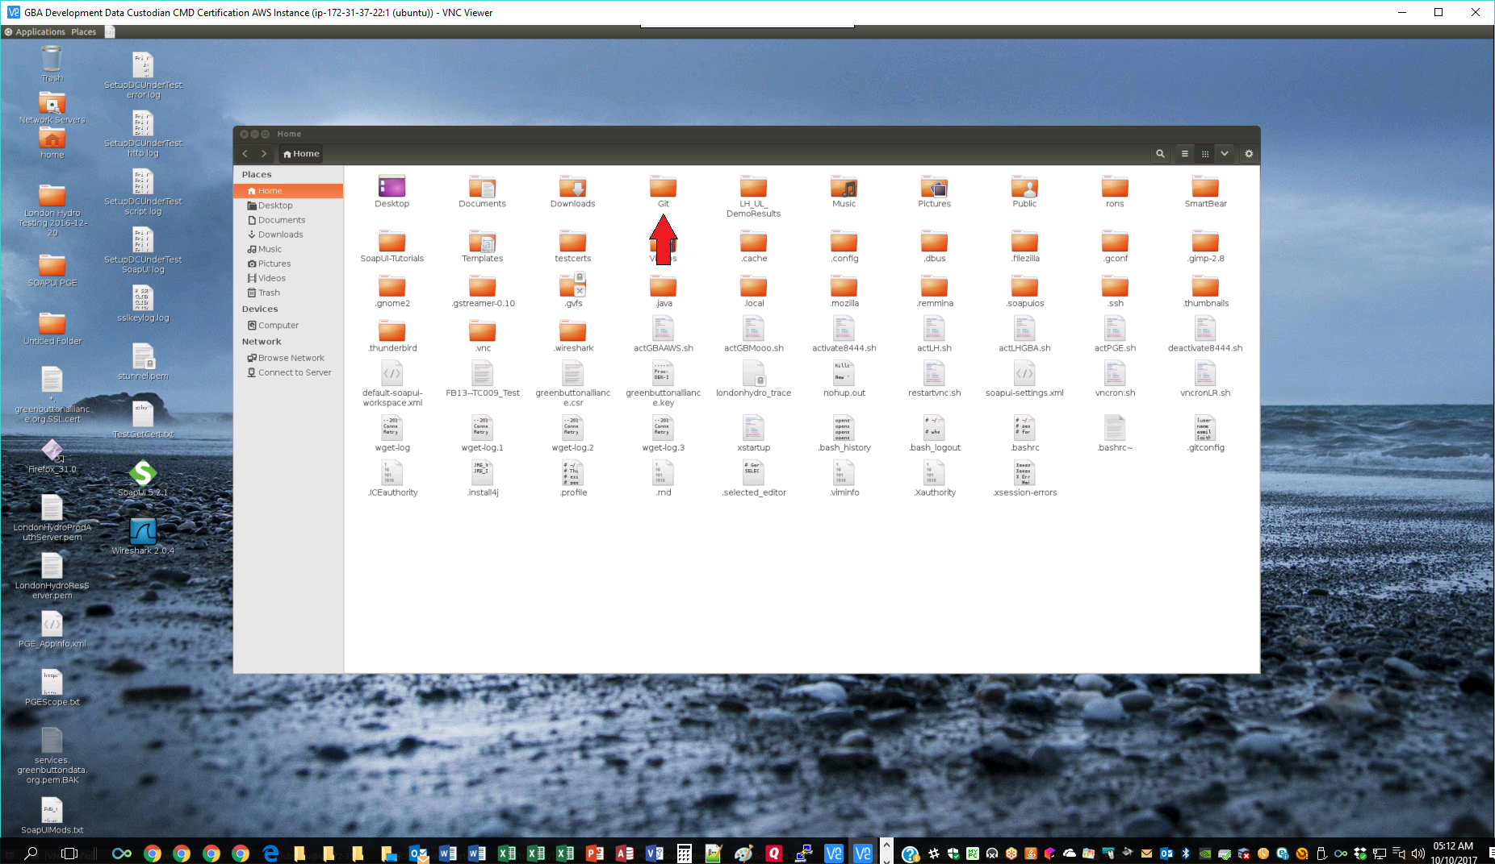
3. Click on the folder labeled “Git”
4. 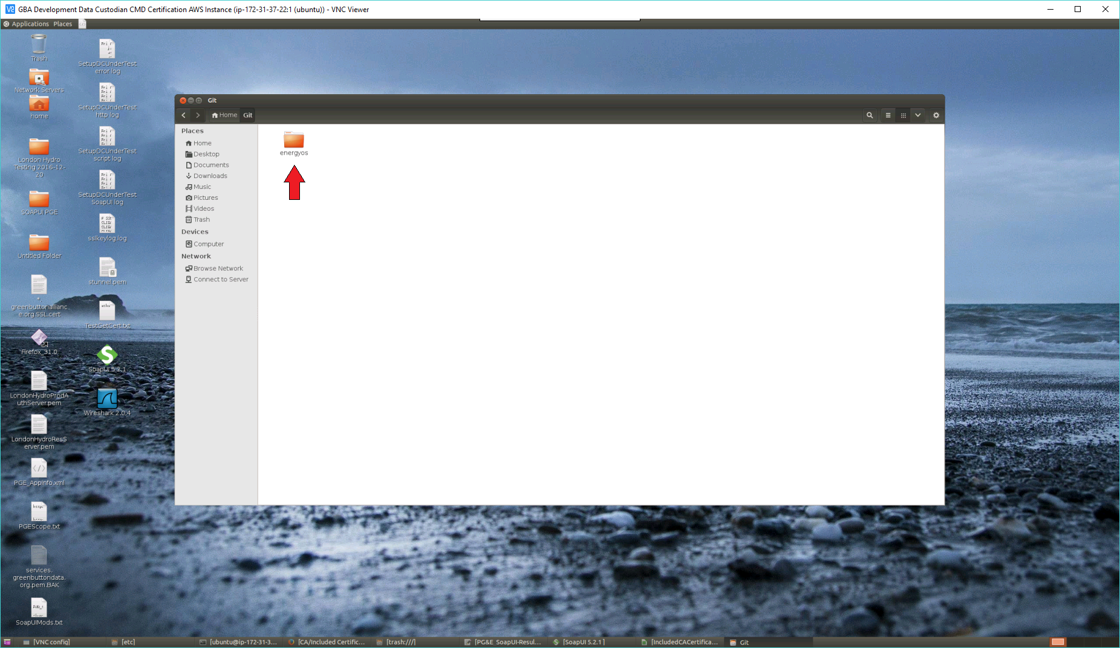
5. Click on the folder labeled “energyos”
6. 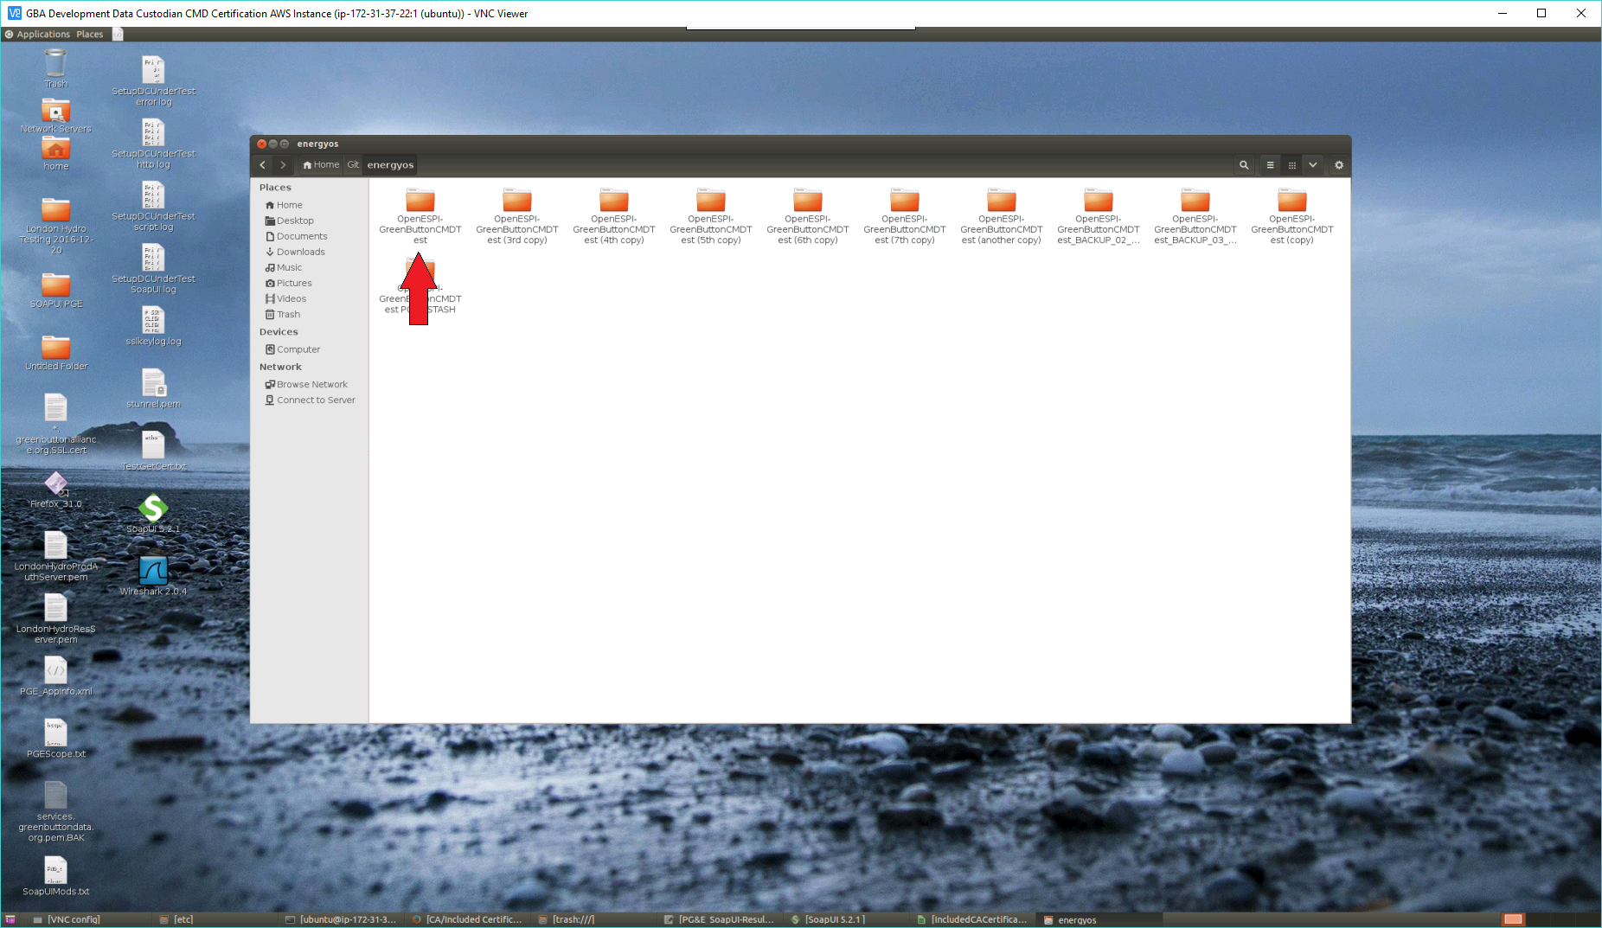
7. Click on the folder labeled “OpenESPI-GreenButtonCMDTest”
8. 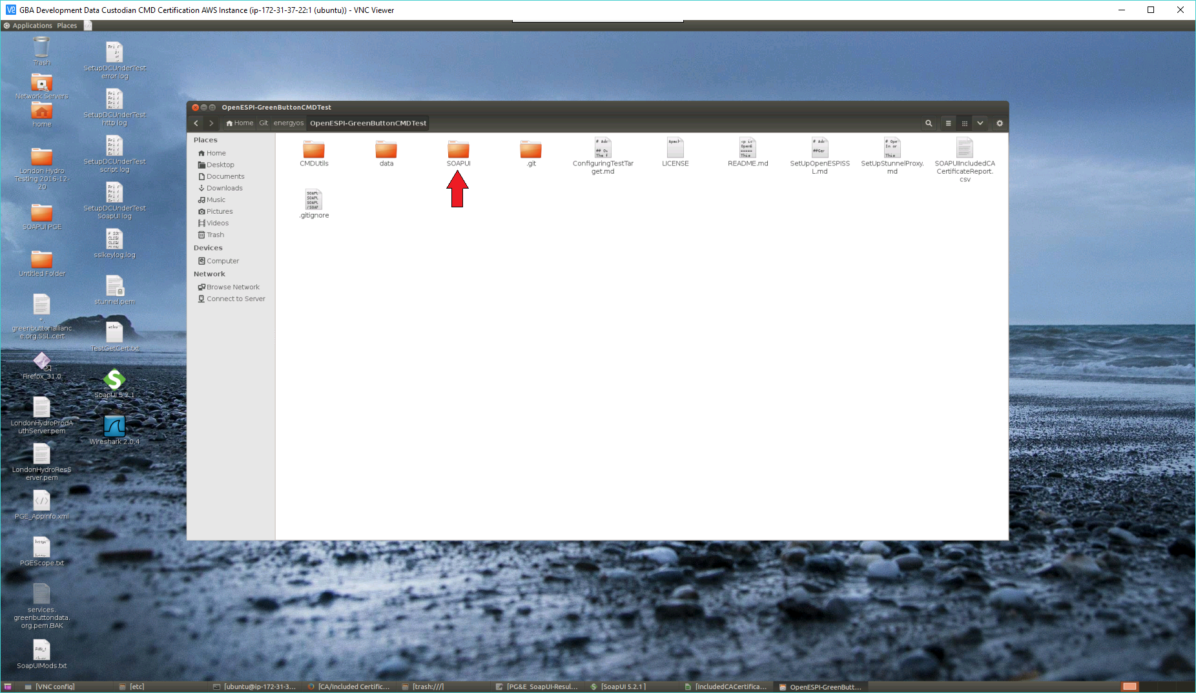
9. Click on the folder labeled “SOAPUI”
10. 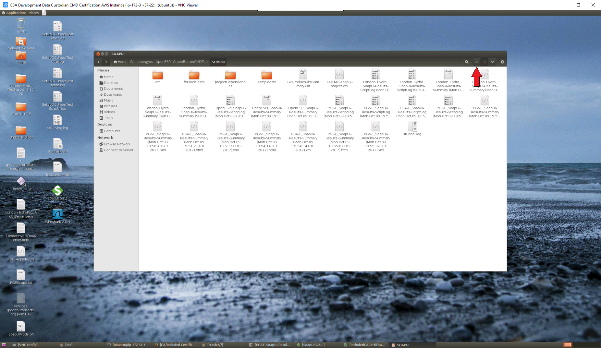
11. Click on the “View items as a list” icon in the upper-right corner of the Files Window
12. 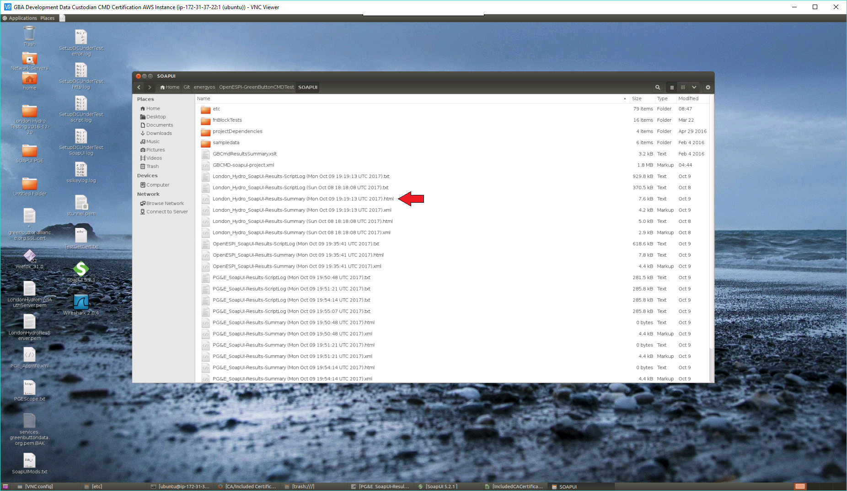
13. Click on the file containing the Certification Applicant’s Name and current date ending in .html
14. Example, London_Hydro_SoapUI-Results-Summary (Sun Oct 08 18:18:08 UTC 2017).html
15. The following will appear showing the Test Configuration and Summary of all Function Block [FB] tests performed  
      
    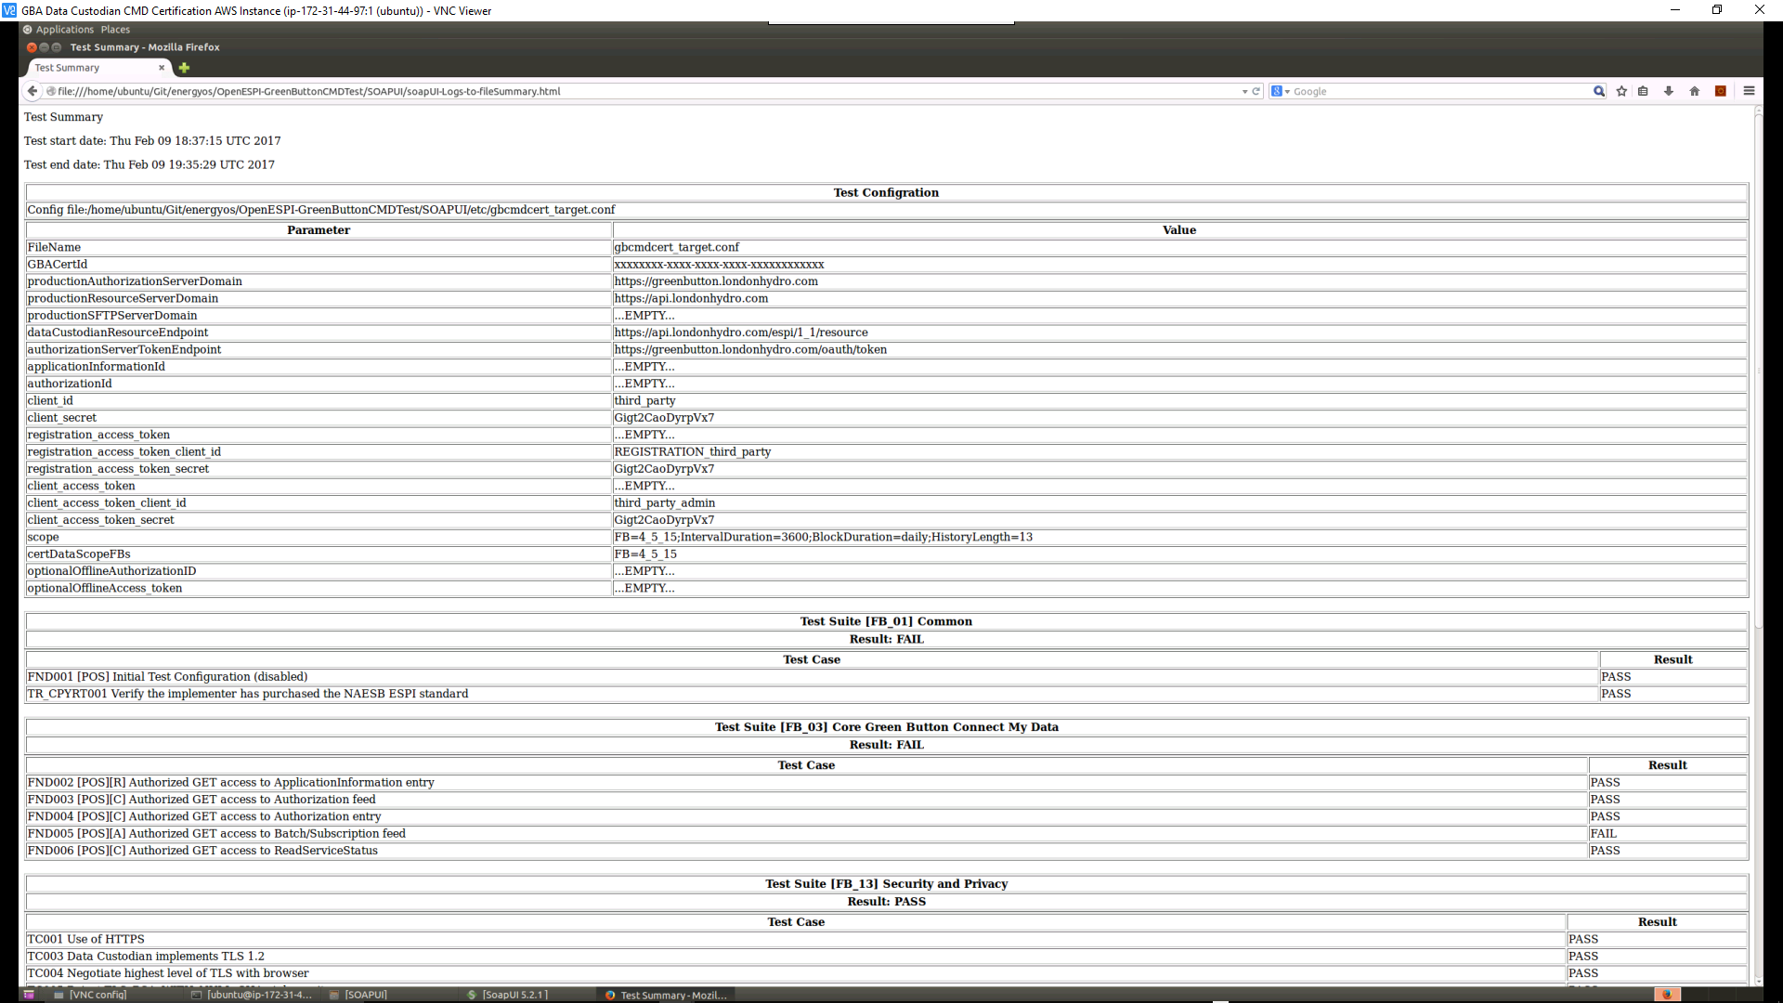
16. Use the scroll bar to see all the results
17. Complete the following attestation section of the results

|  |
| --- |
| <enter any comments or notes> |

__ COMPLIANT __ NONCOMPLIANT Tester Initials: ____ Testee Initials: ____

## Submission of Results to Green Button Alliance

This section describes how to submit the test session results to the Green Button Alliance.

Procedure:

1. If the test applicant results are **COMPLIANT**, perform the following steps:
   1. If the Green Button Data Custodian CMD Test Data Sheet has been maintained in an electronic version, email it as an attachment.
   2. If the Green Button Data Custodian CMD Test Data Sheet has been printed as a hardcopy, scan the document and email the scanned image as an attachment.
   3. Send an e-mail with the test applicant’s name, test date, and completed Green Button Data Custodian CMD Test Data Sheet to:  
       [TestDataSheets@greenbuttonalliance.org](mailto:TestDataSheets@greenbuttonalliance.org)
2. If the test applicant results are **NONCOMPLIANT**, perform the following steps:
   1. Save the completed Green Button Data Custodian CMD Test Data Sheet.
   2. Determine when the test applicant will be able to correct any issues preventing them from achieving a **COMPLIANT** test result and schedule the next testing session.
   3. Once the test applicant has achieved a **COMPLIANT** test result, follow the instructions in section (1) for submission of the **NONCOMPLIANT** and **COMPLIANT** test session Green Button Data Custodian CMD Test Data Sheets.